
How to Share Your Web Pages - on Tripod

Now you’ve created some beautiful pages in Composer. You want to share them with the world. You need to have your pages on a web server. One free server is at www.tripod.com. This handout explains how to sign up and upload your pages.

Signing Up

Go to Mozilla or Internet Explorer.
Type in www.tripod.com

First time: Sign up for a website
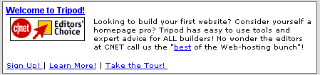
- Click on New Users: Sign Up
- Make sure the Tripod Free button is highlighted.
- Page down and press Continue.
- Choose a username you can remember. A good choice is your email name. It must be unique.
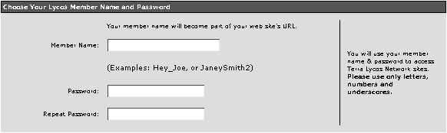
- Choose a password you can remember and enter it. It should be the same as your email password.
- Repeat the password where it tells you to.
- Fill in the rest of the blanks.

- Unless you want a lot of junk email, do not check any Interests or Registration Offers. It’s also a good idea to uncheck all the boxes under Tripod Offers.
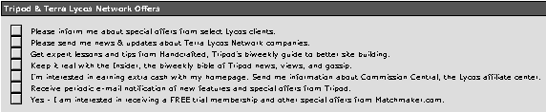
- Enter the confirmation code exactly.
- Finally, click I agree.

If you are lucky, it will work the first time and show you your username and password. WRITE THESE DOWN!
If it doesn’t work, it will tell you what it needs. A common problem is that someone already has the same username. You can accept the name they suggest, or you can click on Let me choose my own name and type in your own.

Uploading Pages

After you have a username and password, you’re ready to upload your web pages.
Go to Tripod.com and click on Log In to log into your Tripod account, if you are not logged in already. Make sure you uncheck “Save member name & password” if you are on a lab computer.
- Click Build in the orange menu bar.
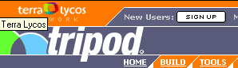
- Click on File Manager.
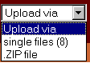
- Pull down Upload via, and choose Single files (8).

- You will see a series of boxes. In the first box, click on Browse and find your file on your disk or hard drive. Make sure all your filenames are lowercase, with no spaces! Click Open to select the file.
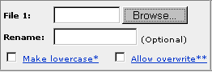
- Go to the next box, click Browse, and continue to find files until you have them all.
- If you are replacing one of your files, you will need to check the Allow overwrite box for that file.
- Click Upload to upload your files.

- Click the Close box to go back to File Manager.
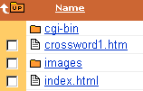
- If you want to see your file, click on its name in File Manager. This will show you what other people will see.

- When you are finished, click Log Out (near the top right corner of the page).

