Using Nicenet for Class Discussion: New Users

Nicenet is a free tool for online discussion. So that we can practice, I’ve created a Nicenet class for us.

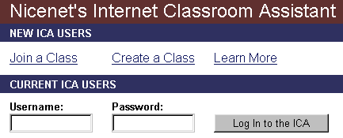
Joining a class:

The FIRST TIME you use Nicenet:

1. Open your web browser and go to http://www.nicenet.org. The first time you use Nicenet, you’ll click on Join a Class. [Note – that’s JOIN a class]
2. Next, type in the Class Key.

My Class Key: ____________ <= this will change if you create your own class
You will not need to type in the class key again.

3. Choose a username and password. The username must be unique in all of Nicenet. Try your last name and first name together with no spaces, or your name with your birthday. The password needs to be at least three letters or numbers long:
My Username: ________________ My Password: _______________

4. Put your email address. You have to type your email address twice. The second one confirms that you typed the first one correctly. Add your real name.

5. When you are finished, click Finish Registration.

6. Type your username and password again to continue.

The next time you use Nicenet, just type in your username and password, then click Log in to the ICA. You’ll be in the class – much easier!

7. Click on Conferencing.

You will see some options at the top:
Message Layout: View Summaries Only | View Entire Messages | Print View
Sort Order: Newest on Top | Newest on Bottom

To read everyone's messages, make sure you see View Entire Messages in italics at the top of the page. If it's underlined, click on it to change it to italics.

8. Click on a topic to read the discussion.

9. After you read the teacher's message, just click Post New Message to write your comment.

10. After you finish, click Post New Message at the bottom to send it.

When you are finished using Nicenet, make sure you click on
LOG OUT
at the bottom of the menubar.

The next time you use Nicenet…
Just type your username and password, then click Log in to the ICA – it’s much simpler.

Don’t forget to LOG OUT when you are finished!

